AnkiDriod-6894

ID-67

Apk

AnkiDroid-2.12.1-x86.apk

<https://github.com/ankidroid/Anki-Android/releases?q=2.12.1&expanded=true>

Bug report description

**1.Original but report:**

**Link**

<https://github.com/ankidroid/Anki-Android/issues/6894>

**Reproduction Steps**

Have (at least) 1h30min due time left.

**Expected Result**

1h30min displayed

**Actual Result**

2h30min displayed

**Debug info**

AnkiDroid Version = 2.12.1  
Android version = 10

Screen shots sequence

Prerequisites:

**Download a complex deck to AVD:**

<https://drive.google.com/u/0/uc?id=1vTHQFSxPLBqfbGcovW95ZfeAJFWrS1WX&export=download>

**Import it to AnkiDriod:**

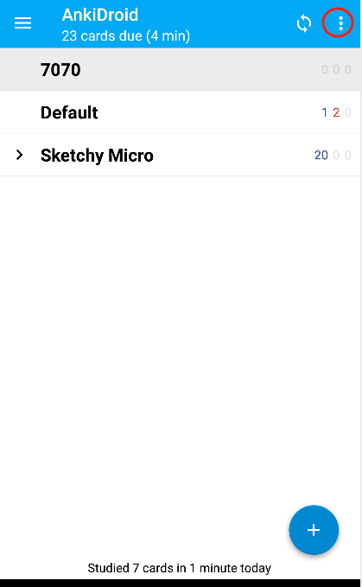

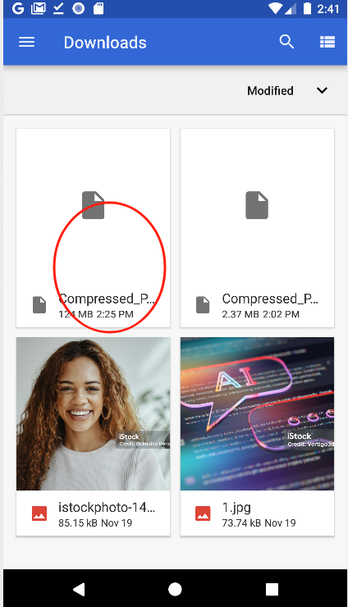

**Bug reproduction sequence:**

**Continue doing the following steps for every card until the time is 1h29min**

**Perform many times then the time due is 1h29m:**

**add one or two more minute using the same steps(123) as above:**

